**Experiment no – 01**

**Aim:** **Set Theory**

**a. Inclusion Exclusion principle.**

**b. Power Sets**

**c. Mathematical Induction**

**Inclusion Exclusion principle:**

**CODE** :

*disp ( 'To find:number of mathematics students taking atleast one of the lamguages French(F),German(G) and Russian(R)' )*

*F =65;*

*G =45;*

*R =42;*

*FandG =20;*

*FandR =25;*

*GandR =15;*

*FandGandR =18;*

*ForGorR =F+G+R-FandG -FandR - GandR + FandGandR ; disp ( ForGorR , ' the number of students studying atleast one of the languages : ')*

**Output:**

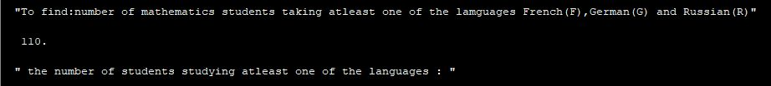

**Power Sets:**

**Code 1:**

*x =3; // number of members o f s e t X*

*P =2^ x // number of members of the power set o f X*

*q=P -1;*

*disp(q, ' number of members of power set P which are proper subsets of x are : ' )*

**Output:**

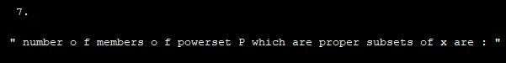

**CODE 2:**

*A=[1 ,2 ,3,4,5]; // eatables for salad preparation 1= onion ,2=tomato ,3= carrot ,4=cabbage ,5=cucumber*

*p= length (A); // t o t a l number of eatables available*

*n=2^p-1; // no salad can be made without at least one of the eatables. Hence null set is not counted*

*disp(n,'number of different salads that can be prepared using the given eatables ')*

**Output:**

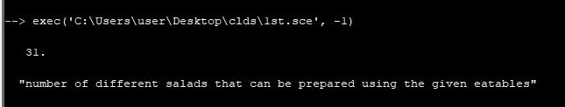

**Mathematical Induction:**

**Code:**

*U1 =1; // g i v e n*

*U2 =5; // g i v e n*

*P =[]; for i =1:2*

*P(i)=3^i -2^ i;*

*disp (P(i))*

*end disp ( 'P( 1 )=U( 1 ) and P( 2 )=U( 2 ) ' );*

*disp ('hence Un=3^n-2^n for all n belonging to N' );*

**Output:**

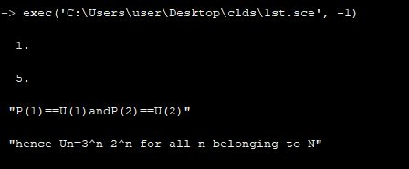

**Conclusion: Successfully performed Set Theory.**

**Experiment no – 02**

**Aim:** **Functions and Algorithms**

**a. Recursively defined functions**

**b. Cardinality**

**c. Polynomial evaluation**

**d. Greatest Common Divisor**

**Recursively defined functions:**

**Code:**

*function [k]=fact(a)*

*k= -1;*

*if(a 200) disp (" I n v a l i d ");*

*break ; else if(a ==1| a ==0)*

*k =1; else k=a* fact (a-1);*

*end end endfunction a =5;*

*p= fact (a);*

*disp (p, ' the v a l u e o f 5! i s ' )*

**Output:**

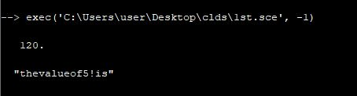

**Cardinality:**

**Code:**

*x =1;*

*y =2;*

*z =3; A=[x,y,z];*

*disp ( ' c a r d i n a l i t y o f s e t A i s : ', length (A) )*

*B=[1 ,3 ,5 ,7 ,9]*

*disp ( ' c a r d i n a l i t y o f s e t B i s : ', length (B) )*

**Output:**

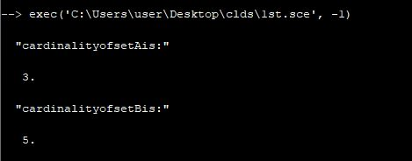

**Polynomial evaluation:**

**Code:**

*x = poly(0,'x');*

*p = 2*x^3 -7*x ^2+4*x -15;*

*disp (p, ' the polynomial is ' ) k= horner (p ,5);*

*disp (k, ' value o f the polynomial at x=5 i s ' )*

**Output:**

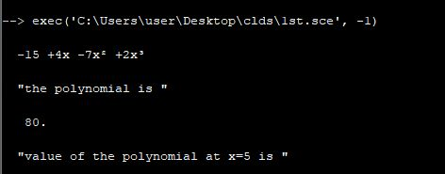

**Greatest Common Divisor:**

*V= int32 ([258 ,60]) ;*

*thegcd = gcd(V);*

*disp (thegcd , ' the gcd o f the two numbers 258 and 60 i s ' )*

**Output:**

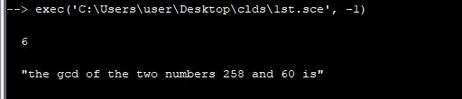

**Conclusion: Successfully performed Functions and Algorithms.**

**Experiment no – 03**

**Aim: Probability Theory 1**

**a. Sample space and events**

**b. Finite probability spaces**

**c. Equiprobable spaces**

**d. Addition Principle**

**Sample space and events:**

**Code:**

*S=[1,2,3,4,5,6];*

*A =[2,4,6];*

*B =[1,3,5];*

*C =[2,3,5];*

*disp(union(A,C),'sample space for the event that an even or a prime number occurs')*

*disp(intersect(B,C),'sample space for the event that an odd prime number occurs')*

*disp(setdiff(S,C),'sample space for the event that a prime number does not occur')*

*intersect (A,B)*

*H=0;*

**Output:**

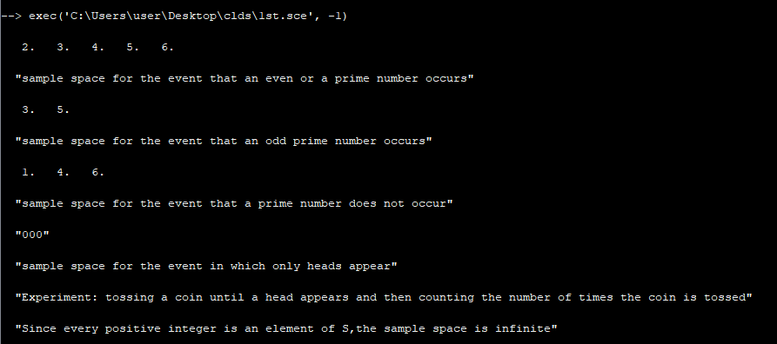

**Finite probability spaces:**

**Code:**

*disp ('Experiment: three coins are tossed and the number of heads are observed' )*

*S=[0,1,2,3];*

*disp (" the probability space is as follows")*

*P0 =1/8;*

*P1 =3/8;*

*P2 =3/8;*

*P3 =1/8;*

*disp ("A i s the event that atleast one head appears and B is the event that all heads or all tails appear ")*

*A =[1 ,2 ,3];*

*B =[0 ,3];*

*PA=P1+P2+P3;*

*disp(PA ,'probability of occurrence of event A')*

*PB=P0+P3;*

*disp(PB,'probability of occurrence of event B')*

**Output:**

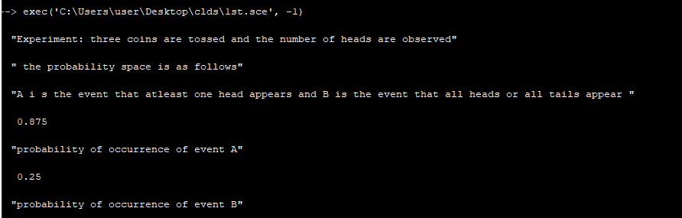

**Equiprobable spaces:**

**Code:**

*disp (" Experiment : a card is selected from a deck of 52 cards ")*

*disp ("A is the event of the selected card being a spade ")*

*disp ("B is the event of the selected card being a face card ")*

*t =52 ;*

*s =13;*

*PA= s/t;*

*disp (PA , 'probability of selecting a spade ' )*

*f =12;*

*PB=f/t;*

*disp (PB , ' probability of selecting a face card ' )*

*sf =3;*

*Psf =sf/t;*

*disp (Psf ," probability of selecting a spade face card is: ")*

**Output:**

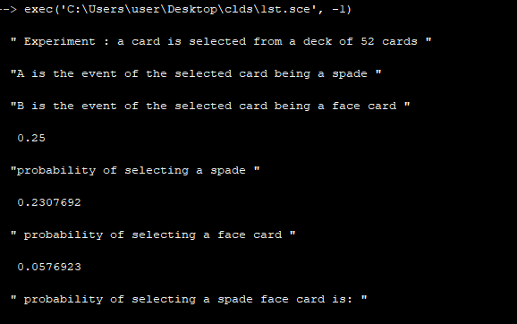

**Addition Principle:**

**Code:**

*disp("Experiment: selection of a student out of 100 students")*

*M =30;*

*C =20;*

*T =100;*

*PM = M/T*

*PC = C/T*

*MnC =10;*

*PMnC = MnC/T*

*PMorC = PM+PC - PMnC ;*

*disp (PMorC,'probability of the selected student taking mathematics or chemistry')*

**Output:**

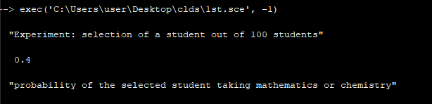

**Conclusion: Successfully performed Probability Theory 1.**

**Experiment no – 04**

**Aim:** **Probability Theory 2**

**a. Conditional Probability**

**b. Multiplication theorem for conditional probability**

**c. independent events**

**d. Repeated trials with two outcomes**

**Conditional Probability:**

**Code:**

*isp("Experiment: A die is tossed and the outcomes are observed");*

*disp ("To find: probability(PM) of an event that one of the dice is 2 if the sum is 6");*

*E=["(1,5)","(2,4)","(3,3)","(4,2)","(5,1)"]*

*A=["(2,1)","(2,2)","(2,3)","(2,4)","(2,5)","(2,6)","(1,2)","(3,2)","(4,2)","(5,2)","(6,2)"]*

*B= intersect (A,E)*

*PM =2/5*

*disp(B,'INTERSECTION OF A AND E')*

*disp(PM,'PROBABILITY')*

**Output:**

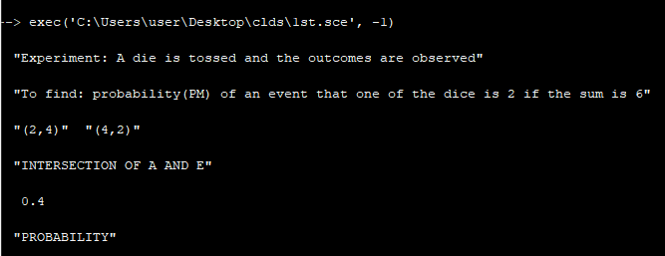

**Multiplication theorem for conditional probability:**

**Code:**

*disp("A bag contains 12 items of which four are defective.Three items are drawn at random,one after the other");*

*s =12;*

*d =4;*

*Pf =(s-d)/s ;*

*Pe=Pf *[(s-d -1) /(s -1) ]*[(s-d -2) /(s -2) ];*

*disp (Pe,'probability that all three items are nondefective')*

**Output:**

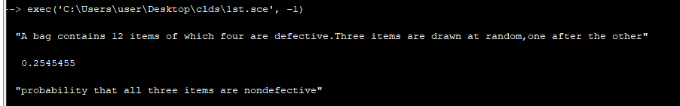

**Independent events:**

**Code:**

*H =1;*

*T =2;*

*S =[111,112,121,122,211,212,221,222]*

*A =[111 ,112 ,121 ,122];*

*B =[111 ,112 ,211 ,212];*

*C =[112 ,211];*

*PA=length(A)/length(S);*

*disp(PA,'probability of A is')*

*PB=length(B)/length(S);*

*disp(PB,'probability of B is')*

*PC=length(C)/length (S);*

*disp(PC,'probability of C is')*

*AnB=intersect(A,B)*

*AnC=intersect (A,C)*

*BnC=intersect (B,C)*

*PAnB=length(AnB)/length(S);*

*disp(PAnB,'probability of the event AnB')*

*PAnC=length(AnC)/length(S);*

*disp(PAnC,'probability of the event AnC')*

*PBnC = length (BnC)/ length (S);*

*disp(PBnC,'probability of the event BnC')*

*if((PA*PB)==PAnB),*

*disp("A and B are independent")*

*else*

*disp("A and B a r e dependent ")*

*end*

*if((PA*PC)==PAnC),*

*disp("A and C are independent")*

*else*

*disp("A and C are dependent")*

*end*

*if (( PB*PC)== PBnC ),*

*disp("B and C are independent ")*

*else*

*disp("B and C are dependent")*

*end*

**Output:**

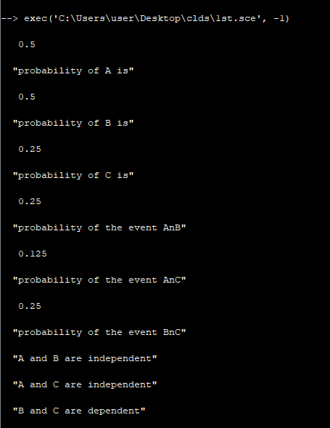

**Repeated trials with two outcomes:**

**Code:**

*disp("Experiment: Three horses race together twice ")*

*Ph1 =1/2;*

*Ph2 =1/3;*

*Ph3 =1/6;*

*S =[11 ,12 ,13 ,21 ,22 ,23 ,31 ,32 ,33]*

*P11 = Ph1 *Ph1*

*P12 = Ph1 *Ph2*

*P13 = Ph1 *Ph3*

*P21 = Ph2 *Ph1*

*P22 = Ph2 *Ph2*

*P23 = Ph2 *Ph3*

*P31 = Ph3 *Ph1*

*P32 = Ph3 *Ph2*

*P33 = Ph3 *Ph3*

*disp (P31,'probability of third horse winning the first race and first horse winning the second race is')*

**Output:**

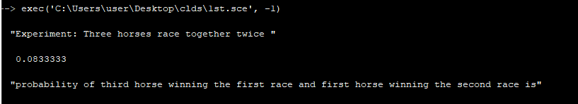

**Conclusion: Successfully performed Probability Theory 2.**

**Experiment no – 05**

**Aim:** **Counting 1**

**a. Sum rule principle**

**b. Product rule principle**

**c. Factorial**

**d. Binomial coefficients**

**Sum rule principle:**

**Code:**

*M =8;*

*F =5;*

*T=M+F ;*

*disp(T,'number of ways students choose calculus')*

*E=[2 ,3 ,5 ,7];*

*F=[2 ,4 ,6 ,8];*

*G=intersect(E,F);*

*H=length(E)+length(F)-length(G);*

*disp(H,'event of getting even or prime number' )*

*E =[11 ,13 ,17 ,19];*

*F =[12 ,14 ,16 ,18];*

*G=union(E,F);*

*k=length(G);*

*disp(k,'no of ways of choosing even and prime no.')*

**Output:**

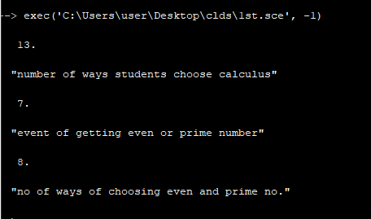

**Product rule principle:**

**Code:**

*disp('A license plate contains two letters followed by three digits where first digit can not be zero')*

*n =26;*

*n*n;*

*p =10;*

*(p -1) *p*p;*

*k=n*n*(p -1) *p*p;*

*disp(k,'tota l number of license plates that can be printed')*

*disp('A president,a secretary and a treasurer has to be elected in an orga nisation of 26 members.No person is elected to more than one position')*

*t =26;*

*j=t*(t -1) *(t -2) ;*

*disp(j,'number of ways to elect the three officers(president,secretary,treasurer')*

**Output:**

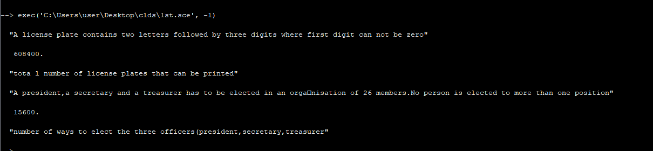

**Factorial:**

**Code:**

*a=factorial(6);*

*disp(a,'value of 6! is');*

*k=factorial(8)/factorial(6);*

*disp(k,'value of 8!/6! is:')*

*j=factorial(12)/factorial(9);*

*disp(j,'value of 12!/9! is:')*

**Output:**

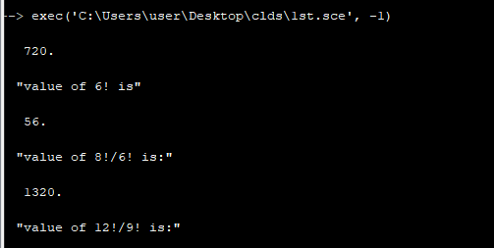

**Binomial coefficients:**

**Code:**

*function[k]=func1(n,r)*

*k=factorial(n)/(factorial(r)*factorial(n-r));*

*disp(n,'n=')*

*disp(r,'r=')*

*disp(k,'k=')*

*endfunction*

*func1(8,2)*

*func1(9 ,4)*

*func1(12,5)*

*func1(10,3)*

*func1(13,1)*

*p=factorial(10)/(factorial(10-7)*factorial(7));*

*q=factorial(10)/(factorial(10-3)*factorial(3));*

*disp(p,'value of 10C7 is')*

*disp(q,'value of 10C3 is')*

**Output:**

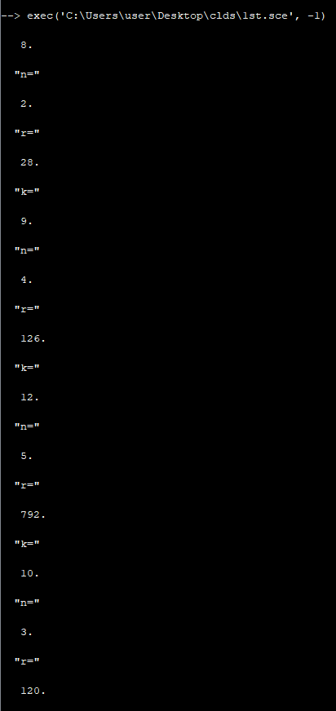

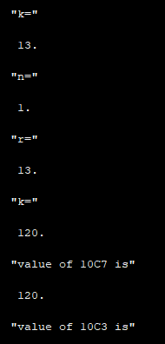

**Conclusion: Successfully performed Counting 1.**

**Experiment no – 06**

**Aim:** **Counting 2**

**a. Permutations**

**b. Permutations with repetitions**

**c. Combinations**

**d. Combinations with repetitions**

**Permutations:**

**Code:**

*disp('finding the number of 3 letter words using only the given 6 letters(A,B,C,D,E,F) without repetition')*

*n =6;*

*l1=n;*

*l2=n-1;*

*l3=n-2;*

*k=l1*l2*l3;*

*disp(k,'number of three letter words possible')*

**Output:**

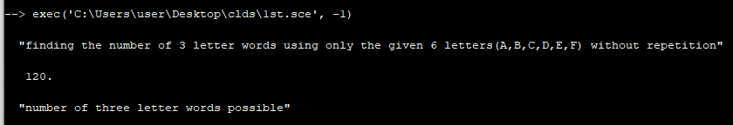

**Permutations with repetitions:**

**Code:**

*function [k]=funct1(n, p, q)*

*k= factorial (n)/( factorial (p)* factorial (q));*

*endfunction*

*k=funct1(7,3,2)*

*disp(k,'The number of seven letter words that can be formed using letters of the word BENZENE')*

*disp('a set of 4 in distinguishable red coloured flags,3 in distinguishable white flags and a blue flag is given')*

*j=funct1(8,4,3);*

*disp(j,'number of different signals,each consisting of eight flags' )*

**Output:**

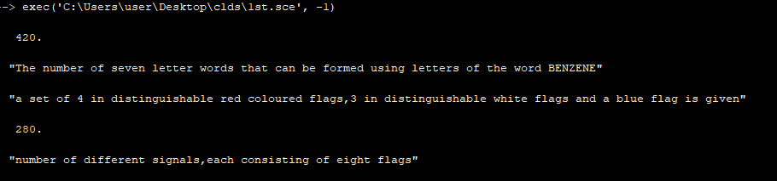

**Combinations:**

**Code:**

*function [k]=myfunc(n, r)*

*k= factorial (n)/( factorial (n-r)* factorial (r));*

*endfunction*

*a= myfunc (8 ,3);*

*disp (a, ' no. of committees of 3 that can be formed out of 8 people is ' )*

*cows = myfunc (6 ,3)*

*disp(cows, 'No of cows=')*

*bulls = myfunc (5 ,2)*

*disp(bulls, 'No of bulls=')*

*hens = myfunc (8 ,4)*

*disp(hens, 'No of hens=')*

*p= cows * bulls * hens ;*

*disp(p,'total number of ways that a farmer can choose all these animals')*

**Output:**

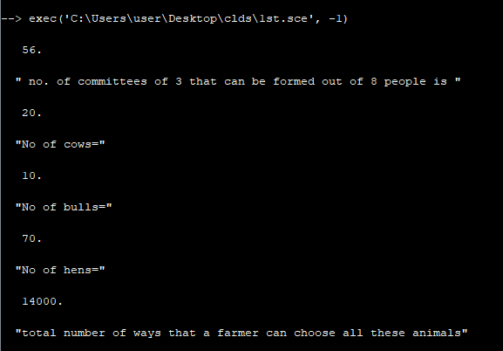

**Combinations with repetitions:**

**Code:**

*r =5;*

*M =2;*

*m= factorial (r+(M -1))/( factorial (r+(M -1) -(M -1) )*factorial (M -1) );*

*disp (m, ' no. of non negative integer solutions of the given equation x+y+z=18 ')*

**Output:**

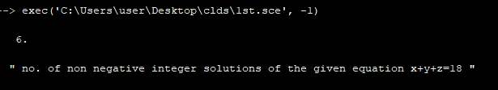

**Conclusion: Successfully performed Counting 2.**

**Experiment no – 07**

**Aim:** **Counting 3**

**a. Ordered partitions**

**b. Unordered partitions**

**Ordered partitions:**

**Code:**

*c1 =3;*

*c2 =2;*

*c3 =2;*

*c4 =2;*

*m= factorial (9) /( factorial (3)* factorial (2)* factorial(2) * factorial (2) );*

*disp(m,'number of ways nine toys can be divide dbetween four children with the youngest son getting 3 toys and others getting 2 each')*

**Output:**

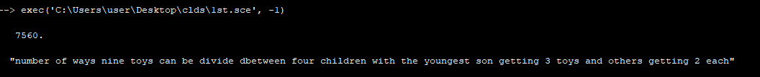

**Unordered partitions:**

**Code:**

*p =12;*

*t =3;*

*disp('each partition of the students can be arranged in 3 ! ways as an ordered partition')*

*r= factorial (12) /( factorial (4)* factorial (4) * factorial(4) )*

*m=r/ factorial (t);*

*disp (m, ' number o f ways that 12 students can be partitioned into three teams so that each team consists of 4 students')*

**Output:**

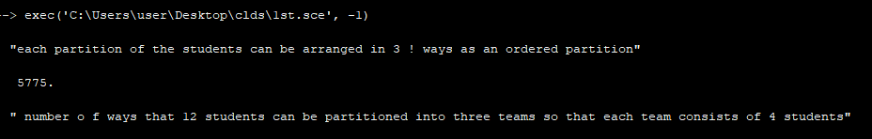

**Conclusion: Successfully performed Counting 3.**

**Experiment no – 08**

**Aim:** **Graph Theory**

**a. Paths and connectivity**

**b. Minimum spanning tree**

**c. Isomorphism**

**Paths and connectivity:**

**Code:**

*disp('given a graph with 6 node sviz . node1 , node2. . . . node6 ' )*

*A =[0 1 0 1 1 0;1 0 1 0 1 0;0 1 0 0 0 1;1 0 0 0 0 0;1 1 0 0 0 0;0 0 1 0 0 0]; disp(A,'The adjacency matrix for A is') disp('sequence A i s a path from node4 to node6 ; but it is not a trail since the edge from node1 to node2 is used twice')*

*B =[0 0 0 1 1 0;0 0 0 0 1 1;0 0 0 0 0 0;1 0 0 0 0 0;1 1 0 0 0 0;0 1 0 0 0 0]; disp(B,'The adjacency matrix for B is') disp('sequence B is not a path since there is no edge from node2 to node6 is used twice')*

*C =[0 0 0 1 1 0;0 0 1 0 1 0;0 1 0 0 1 0;1 0 0 0 0 0;1 1 1 0 0 1;0 0 0 0 1 0]; disp(C,'The adjacency matrix for C is') disp('sequence C is a trail since is no edge is used twice')*

*D =[0 0 0 1 1 0;0 0 0 0 0 0;0 0 0 0 1 1;1 0 0 0 0 0;1 0 1 0 0 0;0 0 1 0 0 0]; disp(D,'The a djacency matrix for D is' ) disp('sequence D is a simple path from node4 to node6')*

**Output:**

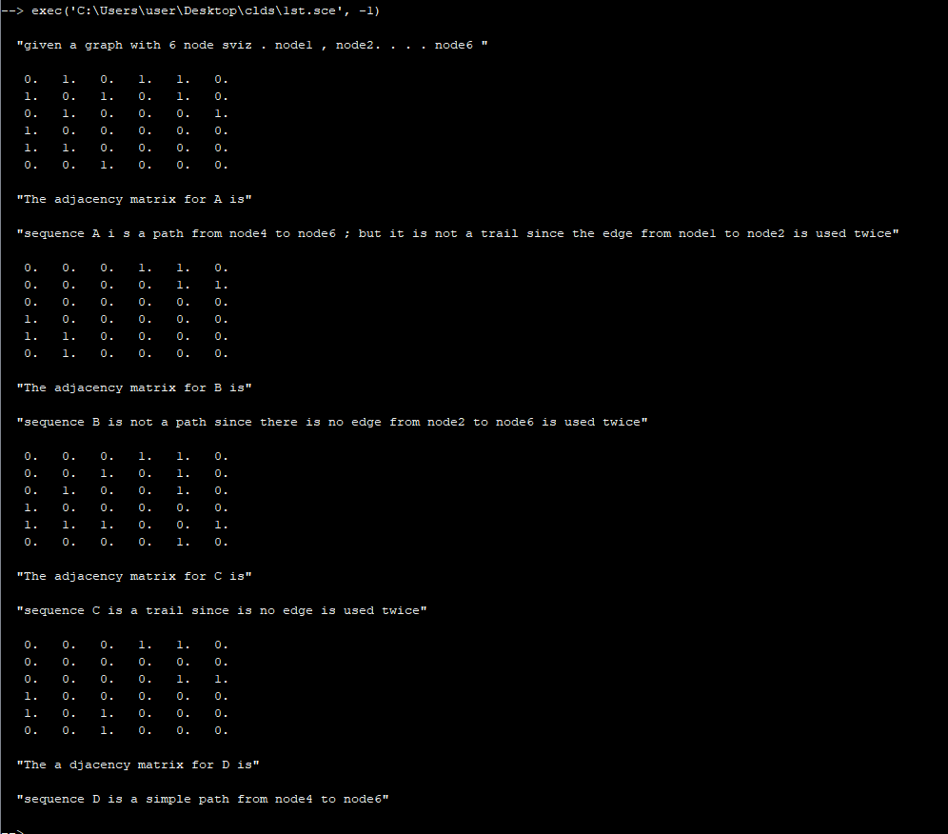

**Minimum spanning tree:**

**Code:**

*disp('to find: minimal spanning tree' )*

*disp('the adjacency matrix for the weighted graph (nodeA , nodeB . . . nodeF )of 6 nodes is :')*

*K =[0 0 7 0 4 7;0 0 8 3 7 5;7 8 0 0 6 0;0 3 0 0 0 4;4 7 6 0 0 0;7 5 0 4 0 0]*

*disp ('edges of the graph')*

*AC =7;*

*AE =4;*

*AF =7;*

*BC =8;*

*BD =3;*

*BE =7;*

*BF =5;*

*CE =6;*

*DF =4;*

*M=[AC ,AE ,AF ,BC ,BD ,BE ,BF ,CE ,DF ];*

*V= int32 (M);*

*L= gsort (V)*

*disp('deleting edges without disconnecting the graph until 5 edges remain' )*

*N=[BE ,CE ,AE ,DF ,BD ];*

*Sum=sum (N);*

*disp(Sum,'weight of the minimal spanning tree is ')*

*disp ( ' another method of finding a minimal spanning tree is : ')*

*K= gsort (V, 'g','i' )*

*N2 =[BD ,AE ,DF ,CE ,AF ];*

*Sum2=sum(N2);*

*disp(Sum2 ,' weight of the minimal spanning tree is' )*

**Output:**

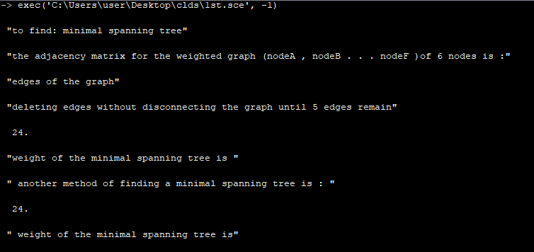

**Isomorphism:**

**Code:**

*A_V=5;*

*R_V=5;*

*A_E=5;*

*R_E=5;*

*A=[0 1 1 0 0;1 0 1 1 0; 1 1 0 0 1;0 1 0 0 0; 0 0 1 0 0];*

*R=[0 1 1 0 0; 1 0 1 1 0; 1 1 0 0 1; 0 1 0 0 0; 0 0 0 0 1]*

*disp(A, 'adjacency matrix for graph A')*

*disp(R,'adjacnecy matrix for graph R');*

*k=0;*

*if (A==R) then*

*for i=1:25*

*if (A(i)==R(i)) then*

*k=k+1;*

*else*

*break;*

*end*

*end*

*end*

*if (k==25) then*

*disp('A and R are isomorphic graphs')*

*else*

*disp('A and R are not isomorphic graphs')*

*end*

**Output:**

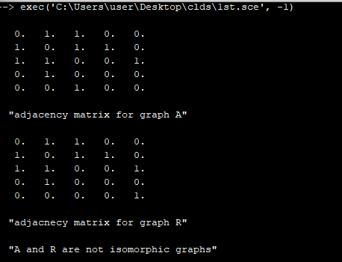

**Conclusion: Successfully performed Graph Theory.**

**Experiment no – 09**

**Aim:** **Directed Graphs**

**a. Adjacency matrix**

**b. Path matrix**

**Adjacency matrix:**

**Code:**

*A=[0 0 0 1;1 0 1 1;1 0 0 1;1 0 1 0];*

*disp (A,'adjacency matrix of graph G is')*

*A2=A^2*

*A3=A^3*

*disp(A2,'the number of ones in A is equal to the no. of edges in the graph ie.8' )*

**Output:**

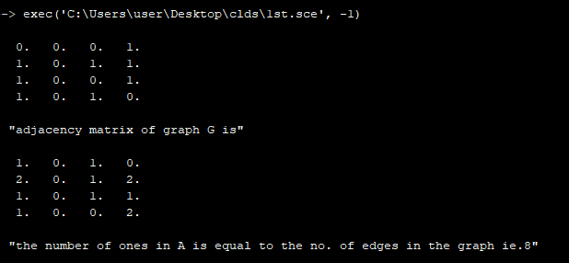

**Path matrix:**

**Code:**

*A =[0 0 0 1;1 0 1 1;1 0 0 1;1 0 1 0];*

*disp (A, ' a d j a c e n c y mat r ix o f graph G i s ' )*

*A4=A^4;*

*A3=A^3;*

*A2=A^2;*

*B4=A+A2+A3+A4;*

*B4 =[4 11 7 7 0 0 0 0 3 7 4 4 4 11 7 7];*

*for i =1:16*

*if(B4(i) ~=0) then*

*B4(i) =1;*

*end*

*end*

*disp (B4,'Replacing non zero entries of B4 with 1 ,we get path (reach ability)matrix P is:')*

*disp('there are zero entries in P,therefore the graph is not strongly connected')*

**Output:**

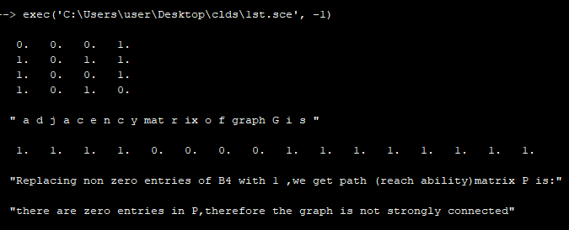

**Conclusion: Successfully performed Directed Graphs.**

**Experiment no – 10**

**Aim:** **Recurrence relations**

**a. Linear homogeneous recurrence relations with constant coefficients**

**b. Solving linear homogeneous recurrence relations with constant coefficients**

**c. Solving general homogeneous linear recurrence relations**

**Linear homogeneous recurrence relations with constant coefficients:**

**Code:**

*a =[];*

*a (1) =1;*

*a (2) =2;*

*disp ('for recurrence relationa(n)=5*a(n-1)-4*a(n-2)+n^2')*

*for n =3:4*

*a(n)=5*a(n-1)-4*a(n-2)+n^2;*

*mprintf(' Value of a(%i ) is:%inn ',n,a(n))*

*end*

*a=[];*

*a(1)=1;*

*a(2)=2;*

*disp('for recurrence relationa(n)=2*a(n-1)*a(n-2)+n^2')*

*for n =3:4*

*a(n)=2*a(n -1)*a(n -2)+n^2;*

*mprintf(' Value of a(%i) is:%inn',n,a(n))*

*end*

*a =[];*

*a (1) =1;*

*a (2) =2;*

*disp('for recurrence relation a(n)=n*a(n-1)+3*a(n-2)')*

*for n =3:4*

*a(n)=n*a(n -1) +3*a(n -2) ;*

*mprintf ( ' Value o f a (%i ) i s : %i nn ' ,n,a(n))*

*end*

*a =[];*

*a (1) =1; // i n i t i a l c o n d i t i o n*

*a (2) =2; // i n i t i a l c o n d i t i o n*

*a (3) =1; // i n i t i a l c o n d i t i o n*

*disp('for recurrence relation a(n)=2*a(n-1)+5*a(n-2)-6*a(n-3)')*

*for n =4:6*

*a(n)=2*a(n -1) +5*a(n -2) -6*a(n -3) ;*

*mprintf ( ' Value o f a (%i ) i s : %i nn ' ,n,a(n))*

*end*

**Output:**

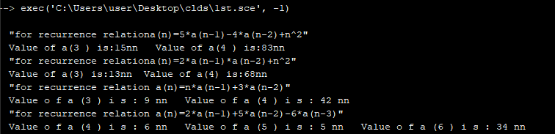

**Solving linear homogeneous recurrence relations with constant coefficients:**

**Code:**

*disp ( ' recurrence relation of Fibonacci numbers f [ n]=f [ n-1]+ f [ n-2] ' )*

*x= poly (0,'x');*

*g=x^2-x -1;*

*disp (g, ' characteristic equation of the recurrence relation is: ')*

*j =[];*

*j= roots (g);*

*disp (j,' roots of the characteristic equation j1 , j 2 ')*

*disp ( ' for general equation fn=Ar^n+Br^n , values of A and B respectively are calculated as:')*

*disp ( ' initial condition at n=0 and n=1 respectively are: ' )*

*f1 =1;*

*D=[ 1.6180340 -0.618034;(1.6180340) ^2 ( -0.618034)^2];*

*K =[1 1];*

*c =[];*

*c=D/K;*

*A=c(1)*

*B=c(2)*

*disp(A,'A=')*

*disp(B,'B=')*

*disp ( ' thus the soluton is f[n]=0.4472136*((1.61834)^n-(-0.4472136)^n)')*

**Output:**

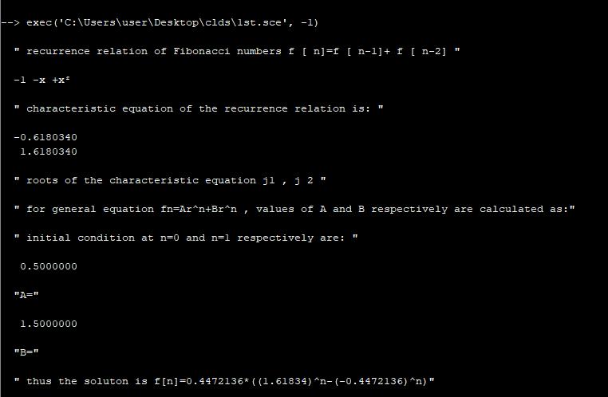

**Solving general homogeneous linear recurrence relations:**

**Code:**

*disp ( 'The recurrence relation a [ n]=11* a [ n-1]-39*a [ n-2]+45* a [ n-3] ' )*

*x= poly (0,'x');*

*disp (g=x ^3 -11* x ^2+39*x -45 , ' character stic polynomial equation for the above recurrence relation' )*

*j =[];*

*j= roots (g);*

*disp (j, ' roots of the character stice quation j1 , j 2 ' )*

*disp ( ' hence the general solution is : a [ n]=c1 *3^ n )+c2 n *3^ n )+c3 *5^ n ) ' )*

*disp ( ' initial condition at n=0 and n=1 respectively are : ' )*

*a0 =5;*

*a1 =11;*

*a2 =25;*

*D =[1 0 1;3 3 5;9 18 25];*

*K =[5 11 25]*

*c =[];*

*c=D/K;*

*c1=c(1)*

*c2=c(2)*

*c3=c(3)*

*disp ( ' thus the s o l u t i o n i s a [ n]=(4-2n )*(3^ n )+5^n ' )*

**Output:**

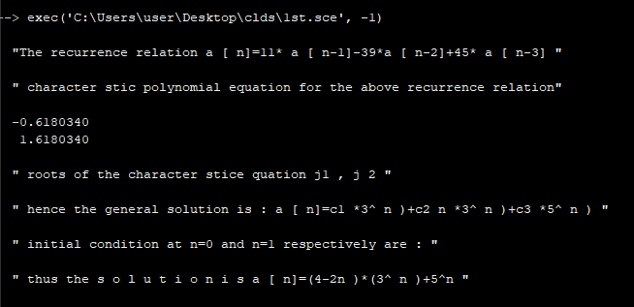

**Conclusion: Successfully performed Recurrence relations.**